**Analysis of Participant Data in Program Offerings**:

Understanding Demographics, Education, and Industry Trends

at Colab Innovation Centre

Prepared by Oluwapelumi Ogundare

April 26th, 2023

# Executive Summary

The analysis of our innovation center's participant data reveals a diverse group primarily in their late 20s to early 40s, with a slight male majority. Participants are highly educated, often holding advanced degrees, from different industries ranging from finance and technology sectors. Program preferences vary by industry and education level, with higher education correlating with specialized program choices. Program cost and duration are linked, and participants prioritize high-value, efficient learning. Salary expectations are high, and remote work flexibility is highly desired. The program enrollment changes seasonally, highlighting the need for strategic program timing. To optimize program offerings, we recommend targeted marketing, diverse program formats, industry alignment, remote work options, and strategic scheduling.

**Table of Contents**

1. Executive Summary 2

2. Background 4

3. Analysis and Findings 4

3.1. Demographics 4

3.2. Education 5

3.3. Industry 5

3.4. Program Details 6

3.5 Salary Benefit and Expectations Post-Completion 7

3.6 Seasonal Trends 8

4. Recommendation 10

5. Conclusion 10

6. References 10

**Table of Figures**

Figure 1: Gender distribution by program enrollment. 5

Figure 2: Program distribution across the educational level. 6

Figure 3: shows the program distribution by industries. 7

Figure 4 shows the cost by Duration. 8

Figure 5 shows the Better salary & Remote Work 8

Figure 6 shows the number of gender by month in 2020 9

Figure 7 shows the number of gender by month in 2021 10

Figure 8 shows the number of genders by month in 2022. 10

# Background

In this report, I analyzed participant data collected from our innovation center. This dataset included details like each participant's unique ID, demographic background, education level, the gender in which they identify, the age of each individual, the industry, the specific programs they completed, and a verbal survey question at the end of each program to understand their salary expectations after the program to what will drive the skills learn which were centered around remote job or better salary. My goal was to provide our board members with actionable insights that would help us improve our program offerings and more effectively meet the diverse needs of our participants.

# Analysis and Findings

## Demographics

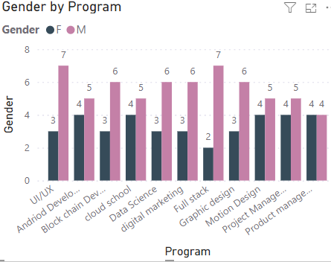My analysis of participant demographics revealed that our programs attracted a diverse mix of ages and genders. Age-wise, we saw participants from a wide range, but most people were in their late 20s to early 40s. Regarding gender, the split was not fully balanced, we had slightly more male participants than female participants during the duration of a timeline (2021-2023). I included charts to visually demonstrate these age and gender distributions.

Figure 1: Gender distribution by program enrollment.

*Figure 1* shows a significant difference in gender representation across various programs. Programs like Digital Marketing and UI/UX have the highest percentage of male students (with a total number of 7 each) while fields like Product Management, Full Stack, and Graphic Design have very low female enrollment (4,4 and 2 respectively). This highlights a potential gender disparity in specific technical program choices.

## Education

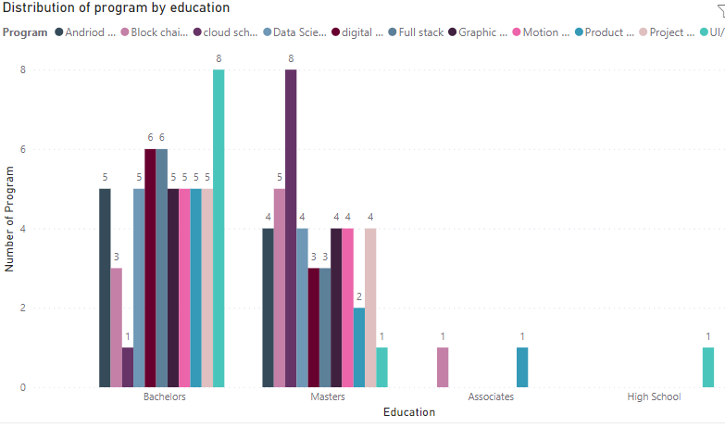When I looked at participant education levels, most had either bachelor's or master's degrees. We also had a smaller number of people with associate degrees or high school diplomas. What was interesting was my correlation analysis – it showed that participants with higher degrees tended to choose our more specialized programs. I included charts to clearly illustrate how education levels varied between the programs we offer.

Figure 2: Program distribution across the educational level.

*Figure 2* shows how many different educational programs are offered at each level, from high school up to a master's degree, specifically focusing on its technology fields. There were 54 participants with bachelor's degrees, 42 with master's degrees 2 with associates, and 1 with high school certificate leading to a total of 99 participants and 11 programs across all educational levels.

### Industry

My analysis showed that the most common industries for our participants were finance and technology, with healthcare and education also well represented. Interestingly, as I dug into the data, I discovered that certain programs attract more people from specific industries. For example, our data science program drew heavily from the technical sector. I've included charts that clearly show these industry participation patterns.

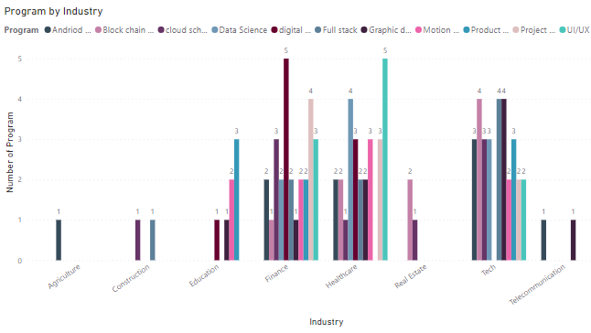

Figure 3: shows the program distribution by industries.

*Figure 3* shows us which industries our participants come from, broken down by the specific program they chose. highlighting some interesting trends, for example, people from the technical sector are much more likely to choose our Data Science program, while those already in education tend to gravitate towards our education program. There were some industries like healthcare and finance in which participants in those programs didn’t have any connection. This helps us understand how different professional sectors view our program offerings.

## Program Details

My analysis revealed that program costs and lengths varied quite a bit. Some programs were significantly more expensive and ran for a longer time than others. Interestingly, I discovered that longer programs were generally more expensive. I've included charts that demonstrate the cost and duration differences between our programs.

Figure 4 shows the cost by Duration.

*Figure 4* tells us that longer programs generally cost more. You can see those short programs, maybe around six months long, cost an average of $50. But those lasting almost 4 months tend to cost $150. This clearly shows that investing in shorter and more valuable programs will usually mean a higher price tag.

### 3.5 Salary Benefit and Expectations Post-Completion

My analysis of salary and benefits showed that pay varied based on the participant's industry and the specific program they completed. There were small differences in pay between men and women as well. Many participants expected to see salary increases or better benefits in their industry after finishing our programs. Additionally, there was a clear preference for remote work options, indicating that people value flexibility. These insights show that it's important I continue to align our programs with both what employers are looking for and the desire for flexible work arrangements. I've included charts that demonstrate the choice of salary benefits and expectations after completing the required program.

*Figure 5* shows us that more participants want a salary boost after completing our programs depending on which program they chose. A percentage of 60% wanted a better salary after completion of the required program as something to look forward to, while 39% were more clinging to finding remote jobs for comfort and openness to paths. This tells us that some of our programs are likely to prepare people for higher-paying careers than others.

Figure 5 shows the Better salary & Remote Work

### 3.6 Seasonal Trends

When I looked at program enrollment data from 2020 to 2022, I noticed some clear seasonal trends for example in 2020 the 3rd quarter of the year there was a wilder increase in participants. For 2021 there was more increase in participants in the 2nd and 3rd quarter of the year and lastly, in 2022 there was a mild range of increase in population during the 1st quarter of the year. The number of people signing up for our programs wasn't always the same some months were much busier than others. I created charts to visualize these enrollment patterns, making it easy to see the peaks and troughs throughout each year.

Figure 6 shows the Number of gender by months in 2020

*Figure 6* shows that people don't sign up for our programs at the same rate all year long. Enrollment numbers go up and down, with a big enrollment spike in male participants towards August, and then a drop-off in the spring and summer months. This showcases that more male audiences are willing to join a skill program towards the summer period where they are more likely to enroll. There was a known turnout in the year 2020 for female audiences to come to our program training.

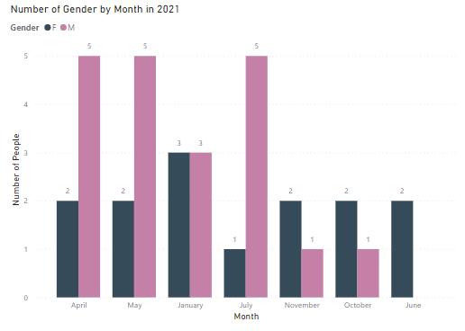

Figure 7 shows the number of gender by months in 2021

*Figure 7* shows that Enrollment numbers increased with male audiences from January to April (winter to spring. This showcases that more male audiences are willing to join a skill program towards the winter period in 2021 where they are more likely to enroll. Based on the news it was predicted to see few numbers as there was a gradual flexibility in timing after COVID-19 started dying down, same as last year (2020), There was a known turnout for female audiences to come to our program training.

Figure 8 shows the number of genders by months in 2022.

*Figure 8* shows that other enrollment numbers increased with male audiences in February 2022. This also indicates that more male audiences are willing to join a skill program towards the winter period in 2022 when they are more likely to enroll. There was a better turnout for female audiences to come to our program training compared to the two previous years (2020 & 2021).

# Recommendation

Based on the analysis, the following recommendations are proposed, integrated with the SWOT insights:

Targeted Marketing: Leverage our strength in diverse locations and departments to focus on specific demographics and industries. This approach can help address the weakness of gender disparity and attract participants to underrepresented programs.

Diverse Program Formats: Offer a mix of short, high-value programs and more specialized long-term programs to meet varying participant needs. This strategy can capitalize on the opportunity to develop efficient learning modules and respond to the demand for flexible, remote learning options.

Industry Alignment: Tailor programs to align with industry demands, ensuring relevance and appeal to prospective participants. This approach can help us maintain a competitive edge and mitigate the threat of external competition.

Remote Work Options: Integrate remote work flexibility into program structures to meet the high demand for remote learning and work opportunities. This strategy aligns with the identified opportunity to differentiate our offerings in a competitive market.

Strategic Scheduling: Use seasonal enrollment trends to optimize program timing and increase participation. This approach can help us maximize enrollment and address the threat of economic fluctuations impacting participant numbers and financial resources.

# Conclusion

In conclusion, by analyzing the data from our innovation center participants, we've discovered some key insights that can help us improve our programs and marketing strategies.

Our participants vary in age and education, with slightly more men than women overall. However, some programs have more men or women, so we need to pay attention to gender balance. We also found that people with higher education are more likely to choose specialized programs, and certain industries are interested in specific courses. This means we need to tailor our marketing to reach the right people.

We also noticed that program cost and length are related, with people preferring shorter, more valuable courses. Many participants expect higher salaries and want to work remotely, so we need to make sure our programs align with what the market is looking for. Additionally, we found that enrollment changes throughout the year, so we can use this information to schedule our programs at the best times to get the most participation.

# References

The analysis utilized SQL for data management and Power BI for data visualization. Additional data was collected from company inventory and surveys using tools like Google Forms Skill analysis pdf.pdf

Colab sql.pdf

Data collection was obtained from company inventory data